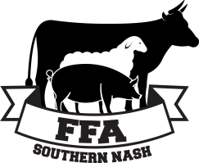
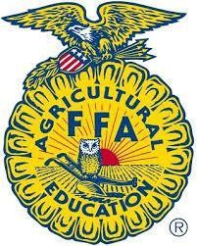
Saturday, March 28, 2020
2020 Southern Nash Blue and Gold Livestock Show
REGISTRATION FORM
Ages 5-19 as of January 1, 2020 - Registration is due by Friday, March 20

Name of Youth Participant: Age (as of January 1, 2020): Date of Birth: Complete Mailing Address: Name of Parents or Guardian (that we can contact regarding this project):

Home #: Work #: Cell #: Parent Email Address: (Communications and Announcements will be sent by email)
Text? Y or N

Youth Cell Number: Can we send reminder text? Y or N
Please indicate the number of animal(s) to be shown (limited to 2 animals per participant) - Cost is $10/animal

Steer
Lamb
Goat

T-Shirt: Please Circle Youth’s Shirt Size (No charge to Age 5 and older Blue and Gold Livestock Participants) Additional T-Shirt Order: Please mark the number of shirts under requested size
Youth Small | Youth Medium | Youth Large | Adult Small | Adult Medium | Adult Large | Adult XL | Adult 2X | Adult 3X

Youth Small – Adult XL $12.00 EACH |  |  |  |  |  |  | $15.00 EACH
Youth Small | Youth Medium | Youth Large | Adult Small | Adult Medium | Adult Large | Adult XL | Adult 2X | Adult 3X
TOTAL T-SHIRT BALANCE:

Complete the table below to combine registration and T-shirt costs for payment total amount.
PAYMENT INFO | AMOUNT | DEADLINE MARCH 20, 2020  Registration Form, Fees, Signature Page, & IAFE Code of Show Ring Ethics  Payable To: Southern Nash FFA  Attn: Kristina Brake  6446 Southern Nash High Road Bailey, NC 27807
Registration Fee - No. of Animals x $10
Additional T-Shirt Cost
TOTAL DUE
Participant Consent & Liability Release
I have read and understand the Rules and Regulations as well as signed the IAFE Code of Show Ring Ethics, and agree to consent and abide by the rules of the competition as stated. I acknowledge that my participation in the 2018 Southern Nash Blue and Gold Livestock show may involve risks including, but not limited to “personal injury or death” and property damage. I assume responsibility for all risks. I indemnify Nash Rocky Mount School System, Southern Nash High School, Southern Nash FFA, its employees, including all teachers, administrators and volunteers working with students in the 2018 Blue and Gold Livestock show, from any liability arising from, or proximately caused by my participation in this program.
Participants Print: Signature: Date: Parent Print: Signature: Date:

CONTACT INFORMATION: Southern Nash High School - Attn: Kristina Brake PH: (252) 451-8520 FAX: (252) 478-5953 EMAIL: kbbrake@nrms.k12.nc.us

